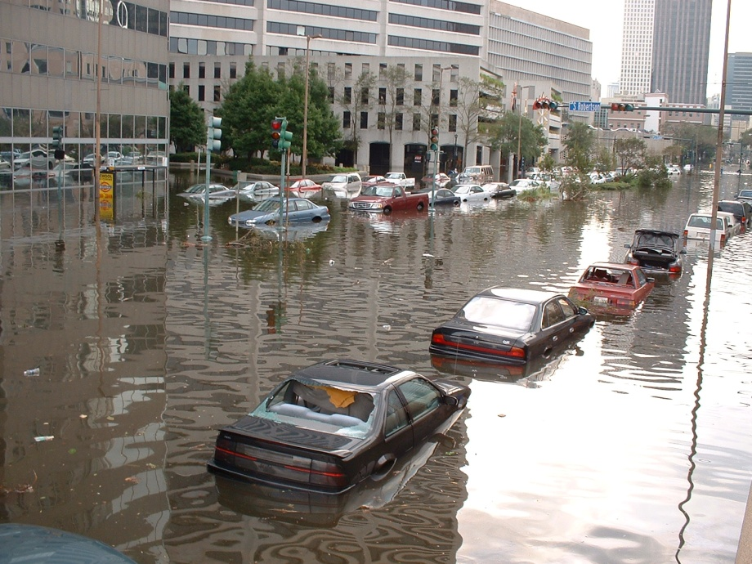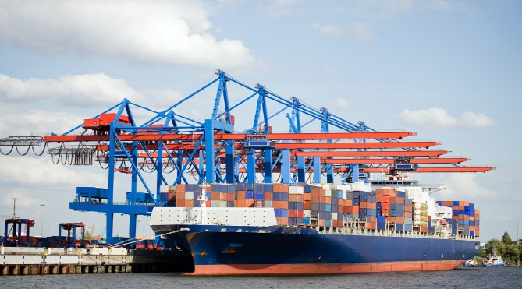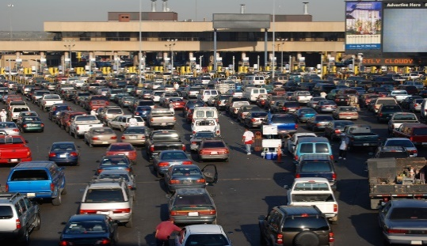Supply Chain Border Closure Tabletop Exercise
  - Situation Manual
  - [Insert Date]
*[Insert Caveat]*
This Situation Manual (SitMan) provides exercise participants with all the necessary tools for their roles in the exercise. Some exercise material is intended for the exclusive use of exercise planners, facilitators, and evaluators, but players may view other materials that are necessary to their performance. All exercise participants may view the SitMan.

This page is intentionally left blank.

Exercise Agenda
Start Time | End Time | Activity
7:45 a.m. | 8:30 a.m. | Registration
8:30 a.m. | 8:45 a.m. | Welcome and Participant Briefing
8:45 a.m. | 9:45 a.m. | Module One: Pre-Incident
9:45 a.m. | 9:55 a.m. | Break
9:55 a.m. | 10:55 a.m. | Module Two: Incident
10:55 a.m. | 11:05 a.m. | Break
11:05 a.m. | 12:05 p.m. | Module Three: Post-Incident
12:05 p.m. | 12:30 p.m. | Hot Wash
*All times are approximate

This page is intentionally left blank.

Exercise Overview
Exercise Name | Supply Chain Border Closure Tabletop Exercise (TTX)
Exercise Dates | [Indicate the start and end dates of the exercise]
Scope | This exercise is a TTX, planned for [insert exercise duration], and will focus on [insert scope].  This exercise was developed using materials created by the Cybersecurity and Infrastructure Security Agency (CISA) for a CISA Tabletop Exercise Package (CTEP).
Mission Area(s) | Prevention, Protection, Mitigation, Response, and Recovery [select appropriate Mission Areas]
Capabilities | Planning; Intelligence and Information Sharing; Risk Management for Protection Programs and Activities; and Supply Chain Integrity and Security
Objectives | - Evaluate how effective current plans, procedures, and agreements are in mitigating and responding to impacts from a catastrophic event to the relevant supply chain  - Identify threats, hazards, vulnerabilities, and consequences for the supply chain.  - Identify critical functions, actions, and timeframes to maintain supply chain continuity due to a catastrophic incident.  - Discuss and validate multidirectional communication processes in accordance with existing supply chain continuity plans and procedures.  - [Insert additional exercise objectives as necessary]
Threat or Hazard | Supply Chain Disruption (Border Closure for Domestic Threat)
Scenario | This is an interactive, discussion-based exercise focused on a border crossing closure resulting from a domestic threat. The scenario consists of three modules: Pre-Incident, Incident, and Post-Incident.
Sponsor | [Insert the name of the sponsor organization, as well as any grant programs being utilized, if applicable]
Participating Organizations | [Please see Appendix A.]
Point of Contact | [Insert the name, title, agency, address, phone number, and email address of the primary exercise point of contact (POC) (e.g., exercise director or exercise sponsor).]

This page is intentionally left blank.

General Information

Exercise Objectives and Capabilities
The following exercise objectives in Table 1 describe the expected outcomes for the exercise. The objectives are linked to capabilities, which are the means to accomplish a mission, function, or objective based on the performance of related tasks, under specified conditions, to target levels of performance. The objectives and aligned capabilities are guided by senior leaders and selected by the Exercise Planning Team (EPT).
Exercise Objectives | Capability
Evaluate how effective current plans, procedures, and agreements are in mitigating and responding to impacts from a catastrophic event to the relevant supply chain. | - Planning  - Intelligence and Information Sharing  - Risk Management for Protection Programs and Activities  - Supply Chain Integrity and Security
Identify threats, hazards, vulnerabilities, and consequences for the supply chain. | - Planning  - Intelligence and Information Sharing  - Risk Management for Protection Programs and Activities  - Supply Chain Integrity and Security
Identify critical functions, actions, and timeframes to maintain supply chain continuity due to a catastrophic incident. | - Planning  - Intelligence and Information Sharing  - Risk Management for Protection Programs and Activities  - Supply Chain Integrity and Security
Discuss and validate multidirectional communication processes in accordance with existing supply chain continuity plans and procedures. | - Planning  - Intelligence and Information Sharing  - Risk Management for Protection Programs and Activities  - Supply Chain Integrity and Security
[Insert objective] | - [Insert capability aligned to each objective]
Table 1. Exercise Objectives and Associated Capabilities

Participant Roles and Responsibilities
The term participant encompasses many groups of people, not just those playing in the exercise. Groups of participants involved in the exercise, and their respective roles and responsibilities, are as follows:
- Players: Personnel who have an active role in discussing or performing their regular roles and responsibilities during the exercise. Players discuss or initiate actions in response to the simulated emergency.
- Observers: Do not directly participate in the exercise. However, they may support the development of player responses to the situation during the discussion by asking relevant questions or providing subject matter expertise.
- Facilitator: Provides situation updates and moderate discussions. They also provide additional information or resolve questions as required. Key EPT members also may assist with facilitation as subject matter experts (SMEs) during the exercise.
- Moderators: Moderators are responsible for admitting and signing in all participants to the virtual exercise, monitoring the chat area for questions and / or issues, and controlling participant audio.
- Evaluators: Are assigned to observe and document the discussion during the exercise, participate in data analysis, and assist with drafting the After-Action Report (AAR).

Exercise Structure
This exercise will be a discussion-based, facilitated exercise. Players will participate in the following three modules:
- Module 1: Pre-Incident
- Module 2: Incident
- Module 3: Post-Incident
Each module begins with a multimedia update that summarizes key events occurring within that time period. After the updates, participants review the situation and engage in discussions of appropriate [insert mission area] issues.

Exercise Guidelines
This exercise will be held in an open, no-fault environment wherein capabilities, plans, systems, and processes will be evaluated. Varying viewpoints, even disagreements, are expected.
Respond to the scenario using your knowledge of current plans and capabilities (i.e., you may use only existing assets) and insights derived from your training.
Decisions are not precedent setting and may not reflect your jurisdiction’s/ organization’s final position on a given issue. This exercise is an opportunity to discuss and present multiple options and possible solutions.
Issue identification is not as valuable as suggestions and recommended actions that could improve [insert mission area] efforts. Problem-solving efforts should be the focus.
The assumption is that the exercise scenario is plausible and events occur as they are presented. All players will receive information at the same time.

Exercise Evaluation
Evaluation of the exercise is based on the exercise objectives and aligned core capabilities. Players will be asked to complete a participant feedback form. These documents, coupled with facilitator observations and notes, will be used to evaluate the exercise and then compiled into the After-Action Report (AAR).

This page is intentionally left blank.

Module One: Pre-Incident

Scenario

[Insert Incident – 48 Hours]: [Time]
An organization monitoring violent extremist websites discovers a video of a masked individual claiming to be from a high-profile extremist organization. In the video, the individual denounced the United States’ influence in a foreign region and promises that “in the coming weeks, the world will know who we are and what we are capable of.” Without threatening to attack a specific target, the speaker claims that they “will strike at the United States when it is in a time of community and peace.”
The monitoring organization forwards the video and translation to the Federal Bureau of Investigation (FBI) for analysis. The intelligence reporting indicates that multiple terrorist cells will attempt to enter the United States through a major border crossing point-of-entry, with bomb materials intended for use in an improvised explosive device (IED) attack against a major population hub. These cells may link up with active terror cells already within the United States to carry out the attack.

24 Hours Later: [Insert Time]
New intelligence reporting indicates a credible threat of a terrorist attack on the homeland. In response to the threat, the FBI and the Department of Homeland Security (DHS) National Operations Center (NOC) issue a Joint Intelligence Bulletin (JIB). The Secretary of Homeland Security issues an Elevated Threat Alert through the National Terrorism Advisory System (NTAS).
In response, open sources report that the U.S. Customs and Border Protection (CBP) may implement stringent security measures at border crossings similar to those implemented following the September 11 attacks. Several major border crossings are rumored to be closing without notice in the coming days. When these types of security measures were implemented following September 11, it created delays ranging from 12-36 hours for all types of traffic crossing the border.

Discussion Questions
- What plans does your organization have to effectively prepare for a potential disruption to your supply chain?
  - Has your organization designated a point of contact (POC) for supply chain continuity?
  - Has your organization conducted an assessment to identify activities that support key products and services provided by your organization?
  - Has your organization identified the transportation concerns that support these activities and key products and services?
  - Do you know which companies are key suppliers for your organization?
    - Have you checked to see if they have a plan or obtained a copy of the plan?
    - Have you probed adequacy of plans and procedures of key suppliers? If so, to what extent?
  - Does your organization have a POC with each critical supplier supporting your key products and services?
  - Have you communicated with your key suppliers so that you understand the actions that they would take to prepare for a terrorist threat and heightened security period?
    - Have you communicated with your key suppliers to understand how, or if, the supplier will meet your order for key supplies?
    - Have you conducted vulnerability assessments for your suppliers and shippers in your supply chain against this type of hazard or threat?
    - Have you identified risk mitigation measures that could decrease the vulnerability of your suppliers and shippers in your supply chain against this type of hazard or threat?
  - Does your organization have alternative suppliers or shippers that support your key products and services?
  - Who is responsible for deciding how goods and materials would be shipped and received once normal operations are disrupted?
- How would your organization receive information from the government regarding this terrorist threat?
  - Does your organization interact regularly with local law enforcement agencies regarding multidirectional information sharing?
  - Does your organization have access to the Homeland Security Information Network – Critical Infrastructure (HSIN-CI) portal?
  - Is your organization familiar with information sharing documents that are posted on HSIN-CI, such as JIBs or DHS Office of Intelligence and Analysis (I&A) Notes?
  - Does your organization maintain a relationship with your CISA Protective Security Advisor (PSA)?
- Does your organization have a process in place that would trigger your supply chain continuity plans? What information does your organization need to trigger and implement supply chain continuity plans?
- In the event of a disruption to your supply chain, what resources does your organization have in place to ensure the security of existing inventories? Are there any gaps or limitations on employing these resources?
- What processes do you have in place to ensure timely information sharing with your supply chain stakeholders?
- To maintain the supply chain and flow of inventory, does your organization have reserve quantities of inventory available at alternate locations?
- If your organization was scheduled to transport supplies through the potentially affected area, is there a process in place to delay shipment orders?
- How will your organization compensate for any unavailability of critical staff related to maintaining the supply chain?
- Does your organization have any obligations that will not be fulfilled because of a disruption to your supply chain? Does your organization have a process in place to communicate these issues to the proper authorities or customers?

This page is intentionally left blank.

Module Two: Incident

Scenario

[Insert Facility Name and Location]

[Insert Month, Day, Year]: [Time]
CBP announces the closure of the El Paso, Laredo, Otay Mesa, Detroit, and Champlain border crossings to commercial vehicles, passenger vehicles, and pedestrian traffic. CBP also announced the enforcement of stringent security measures at most other crossings. The border closures immediately trigger disruptions to intermodal freight transport throughout the United States as trucks reroute on both sides of the closed border crossings, crowding alternate points-of-entry and resulting in delays at the remaining open border crossings.
Rail freight and container ships are delayed in receiving their goods from trucks and delivering their goods to the end users because the network of commercial trucking is delayed nationwide. Factories near closed border crossings that use just-in-time manufacturing experience delays in assembly lines soon after the closures.
Deliveries to retailers are severely disrupted. Many of the Nation’s leading retailers, who rely on just-in-time delivery, are beginning to experience delays in replenishment of goods, including consumer basics such as bottled water, canned goods, and paper products. Even those facilities (grocery stores, banks, and healthcare facilities) that provide essential products and services are experiencing impacts from the border closures as these facilities rely on just-in-time delivery to keep inventory levels as low as possible, which requires frequent deliveries to replenish basic goods.

Discussion Questions
- How would your organization receive information regarding these border crossing closures?
  - Do you use local resources, such as local law enforcement agencies or the media?
  - Does your organization have access to the HSIN-CI?
  - Is your organization familiar with information sharing documents that are posted on HSIN-CI, such as JIBs or DHS I&A Notes?
- What functions of your organization would be impacted if your organization was unable to receive and ship goods and materials?
- Does your organization have a process to communicate with employees who will be affected by the impact to your supply chain (warehouse employees, factory line workers, etc.)?
- What alternative transport methods are you using in your supply chain flow plan, as a result of these border crossing closures?
  - Who is responsible for deciding how goods and materials will be shipped and received once normal operations are disrupted?
- Has your organization collaborated with supply chain stakeholders to develop contingency plans and processes to maintain the safety and security of all personnel, cargo, and equipment during these border crossing closures?
- Who needs to be informed if normal operations are disrupted? What information needs to be provided? How is this information communicated?
- How does your organization operate in the face of a disruption to your supply chain for an uncertain period of time?
- How long can your organization withstand a complete or partial stoppage of incoming raw materials before depletion of on-hand inventories? What are your plans to prevent that from occurring?
- How are contracts with clients and suppliers prioritized for fulfillment during a disruption to the supply chain?

Module Three: Post-Incident

Scenario

[Insert Facility Name and Location]

[Insert Incident + 24 Hours]: [Time]
The El Paso, Laredo, Otay Mesa, Detroit, and Champlain border crossings have reopened, but delays remain. The effects of the border crossing closures are being felt nationwide. Stringent security measures at other border crossings have been relaxed.
There is at least a one- to two-day backup of commercial and passenger vehicle traffic waiting to enter the United States. Freight rail, barge, containerships, and air cargo carriers are also delayed as they await shipments from vehicles delayed at the border points-of-entry.

Discussion Questions
- How would your organization return to normal operations once the border crossings have reopened and the heightened security measures have been lifted?
  - Will your organization need to surge to overcome the delays caused by the border crossing closures?
  - If you do need to surge, do you have a plan to accommodate the additional workload?
- Would your organization use alternative transport modes to regain normal operations?
  - Who is responsible for deciding how goods and materials would be shipped and received if normal operations were disrupted?
  - Who would need to be informed that normal operations were disrupted? What information would be provided? How would this information be communicated?
- How are contracts with clients and suppliers prioritized for fulfillment during a disruption to the supply chain?
- What functions of your organization would be impacted if your organization was unable to receive and ship goods and materials for an extended period of time?
- Would your organization modify its supply chain continuity plans and procedures following such an incident?
- How does your organization measure the progress and effectiveness of its supply chain security activities?

This page is intentionally left blank.

Appendix A: Exercise Participants
Participating Private Sector Organizations
[Insert private sector participants]

Participating Local Organizations
[Insert local participants]

Participating State Organizations
[Insert state participants]

Participating Federal Organizations
[Insert federal participants]

Other Participating Organizations
[Insert other participants]

This page is intentionally left blank.

Appendix B: Relevant Plans
[Insert excerpts from relevant plans, policies, or procedures to be tested during the exercise.]

This page is intentionally left blank.

Appendix C: Acronyms
Acronym | Term
AAR | After-Action Report
CBP | U.S. Customs and Border Protection
CI | Critical Infrastructure
CISA | Cybersecurity and Infrastructure Security Agency
CTEP | CISA Tabletop Exercise Package
DHS | Department of Homeland Security
EPT | Exercise Planning Team
FBI | Federal Bureau of Investigation
HSIN | Homeland Security Information Network
I&A | Office of Intelligence and Analysis
IED | Improvised Explosive Device
IP | Improvement Plan
JIB | Joint Intelligence Bulletin
NOC | National Operations Center
NTAS | National Terrorism Advisory System
POC | Point of Contact
PSA | Protective Security Advisor
SitMan | Situation Manual
SME | Subject Matter Expert
TTX | Tabletop Exercise

