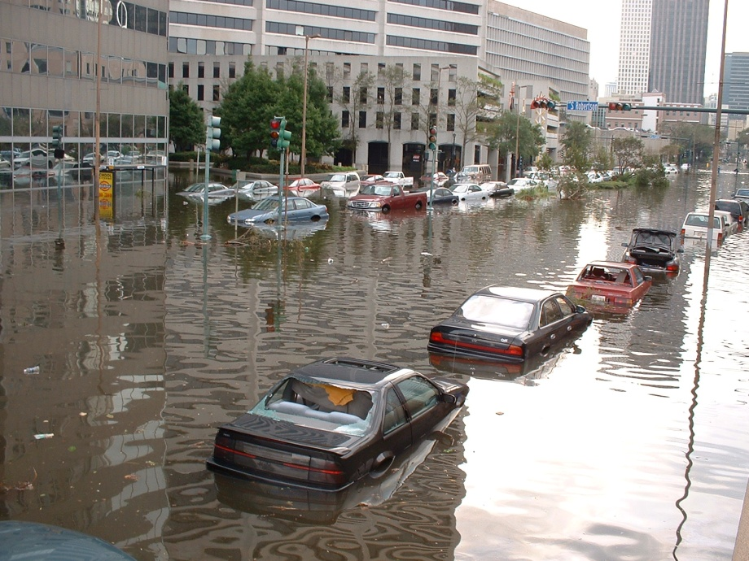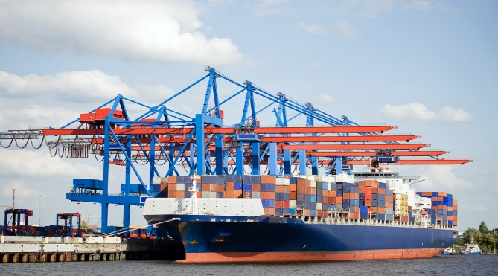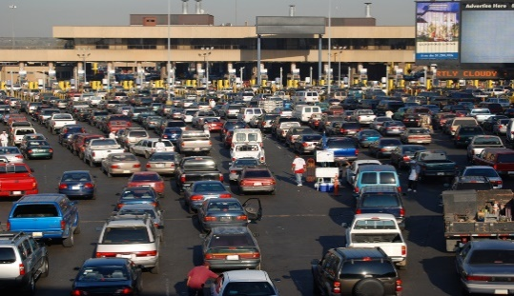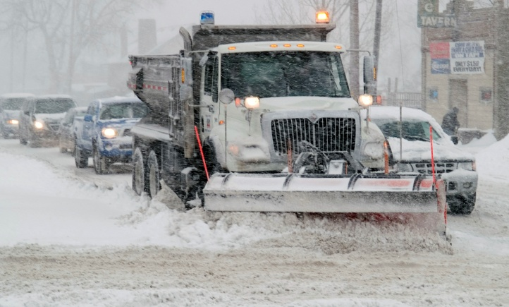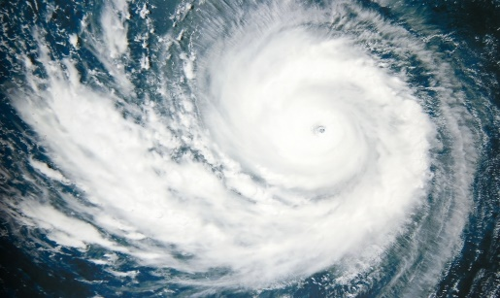

Supply Chain Winter Weather Tabletop Exercise
  - Situation Manual
  - [Insert Date]
*[Insert Caveat]*
This Situation Manual (SitMan) provides exercise participants with all the necessary tools for their roles in the exercise. Some exercise material is intended for the exclusive use of exercise planners, facilitators, and evaluators, but players may view other materials that are necessary to their performance. All exercise participants may view the SitMan.

This page is intentionally left blank.

Exercise Agenda
Start Time | End Time | Activity
7:45 a.m. | 8:30 a.m. | Registration
8:30 a.m. | 8:45 a.m. | Welcome and Participant Briefing
8:45 a.m. | 9:45 a.m. | Module One: Pre-Incident
9:45 a.m. | 9:55 a.m. | Break
9:55 a.m. | 10:55 a.m. | Module Two: Incident
10:55 a.m. | 11:05 a.m. | Break
11:05 a.m. | 12:05 p.m. | Module Three: Post-Incident
12:05 p.m. | 12:3 p.m. | Hot Wash
*All times are approximate

This page is intentionally left blank.

Exercise Overview
Exercise Name | Supply Chain Winter Weather Tabletop Exercise (TTX)
Exercise Dates | [Indicate the start and end dates of the exercise]
Scope | insert This exercise is a TTX planned for [insert exercise duration], at [exercise location]. Exercise play is limited to [insert exercise parameters].  This exercise was developed using materials created by the Cybersecurity and Infrastructure Security Agency (CISA) for a CISA Tabletop Exercise Package (CTEP).
Mission Area(s) | Prevention, Protection, Mitigation, Response, and Recovery [Select appropriate Mission Areas]
Capabilities | Planning; Intelligence and Information Sharing; Risk Management for Protection Programs and Activities; and Supply Chain Integrity and Security.
Objectives | - Evaluate how effective current plans, procedures, and agreements are in mitigating and responding to and recovering from impacts from a catastrophic event to the relevant supply chain.  - Identify threats, hazards, vulnerabilities, and consequences for the supply chain.  - Identify threats, hazards, vulnerabilities, and timeframes to maintain supply chain continuity due to a catastrophic incident.  - Discuss and validate multidirectional communication processes in accordance with existing supply chain continuity plans and procedures.  - [Insert additional exercise objectives as necessary]
Threat or Hazard | Supply Chain Disruption (Winter Weather)
Scenario | This is an interactive, discussion-based exercise focused on a supply chain disruption resulting a winter weather event. The scenario consists of three modules: Pre-Incident, Incident, and Post-Incident.
Sponsor | [Insert the name of the sponsor organization, as well as any grant programs being utilized, if applicable]
Participating Organizations | [Insert a brief summary of the total number of participants and participation level (i.e., federal state, local, tribal, non-governmental organizations [NGOs], private sector, and / or international agencies)]. Consider including the full list of participating agencies in Appendix A. Delete Appendix A if not required.
Point of Contact | [Insert the name, title, agency, address, phone number, and email address of the primary exercise POC (e.g., exercise director or exercise sponsor).]

General Information

Exercise Objectives and Capabilities
The following exercise objectives in Table 1 describe the expected outcomes from the TTX. The objectives are linked to capabilities, which are the means to accomplish a mission, function, or objective based on the performance of related tasks, under specified conditions, to target levels of performance. The objectives and aligned capabilities are guided by senior leaders and selected by the Exercise Planning Team (EPT).
Exercise Objectives | Capability
Evaluate how effective current plans, procedures, and agreements are in mitigating and responding to and recovering from impacts from a catastrophic event to the relevant supply chain. | - Planning  - Intelligence and Information Sharing  - Risk Management for Protection Programs and Activities  - Supply Chain Integrity and Security
Identify threats, hazards, vulnerabilities, and consequences for the supply chain. | - Planning  - Intelligence and Information Sharing  - Risk Management for Protection Programs and Activities  - Supply Chain Integrity and Security
Identify critical functions, actions, and timeframes to maintain supply chain continuity due to a catastrophic incident. | - Planning  - Intelligence and Information Sharing  - Risk Management for Protection Programs and Activities  - Supply Chain Integrity and Security
Discuss and validate multidirectional communication processes in accordance with existing supply chain continuity plans and procedures. | - Planning  - Intelligence and Information Sharing  - Risk Management for Protection Programs and Activities  - Supply Chain Integrity and Security
[Insert additional objectives as necessary] | - [Insert additional capabilities as necessary]
Table 1. Exercise Objectives and Associated Capabilities

Participant Roles and Responsibilities
The term participant encompasses many groups of people, not just those playing in the exercise. Groups of participants involved in the exercise, and their respective roles and responsibilities, are as follows:
Players: Personnel who have an active role in discussing or performing their regular roles and responsibilities during the exercise. Players discuss or initiate actions in response to the simulated emergency.
Observers: Do not directly participate in the exercise. However, they may support the development of player responses to the situation during the discussion by asking relevant questions or providing subject matter expertise.
Facilitator: Provides situation updates and moderate discussions. They also provide additional information or resolve questions as required. Key EPT members also may assist with facilitation as subject matter experts (SMEs) during the exercise.
Evaluators: Evaluators are assigned to observe and document certain objectives during the exercise. Their primary role is to document player discussions, including how and if those discussions conform to plans, policies, and procedures.

Exercise Structure
This exercise will be a discussion-based, facilitated exercise. Players will participate in the following three modules:
- Module 1: Pre-Incident
- Module 2: Incident
- Module 3: Post-Incident
Each module begins with a multimedia update that summarizes key events occurring within that time period. After the updates, participants review the situation and engage in discussions of appropriate [insert mission area] issues.

Exercise Guidelines
This exercise will be held in an open, no-fault environment wherein capabilities, plans, systems, and processes will be evaluated. Varying viewpoints, even disagreements, are expected.
Respond to the scenario using your knowledge of current plans and capabilities (i.e., you may use only existing assets) and insights derived from your training.
Decisions are not precedent setting and may not reflect your jurisdiction’s/ organization’s final position on a given issue. This exercise is an opportunity to discuss and present multiple options and possible solutions.
Issue identification is not as valuable as suggestions and recommended actions that could improve [insert mission area] efforts. Problem-solving efforts should be the focus.
The assumption is that the exercise scenario is plausible, and events occur as they are presented. All players will receive information at the same time.

Exercise After-Action Reporting
CISA will not evaluate exercise players or agencies. Players will be asked to complete participant feedback forms, which, coupled with data collector observations and notes, will be used to assess the exercise and compile an AAR. CISA can provide an Improvement Plan (IP) template for use when requested to assist in future improvement planning efforts.
Exercise Assumptions and Artificialities
In any exercise, assumptions and artificialities may be necessary to complete play in the time allotted and / or account for logistical limitations. Exercise participants should accept that assumptions and artificialities are inherent in any exercise and should not allow these considerations to negatively affect their participation. During this exercise, the following apply:
- The scenario for this exercise is fictitious and does not represent any actual intelligence.
- The scenario is plausible, and events occur as they are presented.
- There are neither “hidden agendas” nor any “trick questions.”
- The exercise is conducted in a no-fault learning environment wherein capabilities, plans, systems, and processes will be evaluated.
- All players receive information at the same time.
- Assume cooperation and support from other responders, agencies, and organization entities.

Exercise Evaluation
Evaluation of the exercise is based on the exercise objectives and aligned core capabilities. Players will be asked to complete a participant feedback form. These documents, coupled with facilitator observations and notes, will be used to evaluate the exercise and then compiled into the After-Action Report (AAR).
Virtual Tabletop Exercise Guidance
In the event that the exercise would need to be executed virtually, the Exercise Planning Team should ensure that all participants have access and are able to use the same virtual platform system (e.g., Microsoft Teams, Adobe Connect, Cisco WebEx, LiveStream Studio, Homeland Security Information Network [HSIN]).
Invitations should include verbiage that directs participants to the virtual platform system link, as well as additional instructions on what role they are expected to play. The Situation Manual and Feedback Form should both be attached to the invitation.
Additionally, the “Participant Roles and Responsibilities” section above will need to be adjusted for the updated conduct format. Multiple facilitators, moderators, and data collectors should be identified to ensure that the exercise can progress if technological issues are encountered. The recommended additions and modifications to the roles and suggested quantity of each are as follows:
- Players: Players will be encouraged to utilize their camera feed while participating in the exercise as they normally would, but will be able to mute their microphones, as necessary.
- Observers: Observers will not engage their cameras but are encouraged to use the chat function to provide questions and comments after each module, in addition to their duties outline above. Observers should be allowed access to the exercise 15 prior to conduct.
- Facilitators (2): Facilitators will be given a presenter role, alongside duties outlined above. Their camera feed should be pinned to the discussion focus area and the facilitator should provide the initial role call for all players.
- Moderators (2): Moderators are responsible for admitting and signing in all participants to the virtual exercise, monitoring the chat area for questions, and muting observer participants. Ideally, one moderator will allow access to outside organizations prior to conduct and control the chat box, while the other signs in participants and controls audio. Neither moderators should engage their cameras during their exercise.
- Data Collectors (2): Data collectors observe and record the discussions during the exercise, participate in data analysis, and draft the AAR/
- Evaluators (2): Evaluators are assigned to observe and document certain objectives during the exercise. Their primary role is to document player discussions, including how and if those discussions conform to plans, policies, and procedures.
Be aware that in hosting a virtual exercise, some limitations may need to be addressed, including connectivity issues, challenges with data collection, unfamiliarity with virtual platforms, and / or an inability to include external stakeholders. Most of these issues, however, can be addressed by examining capabilities and performing test runs with participants (not players or observers) prior to conduct.

Module One: Pre-Incident

Scenario

[Insert Location]

[Insert Incident – 72 Hours]
Much of the United States is in the midst of unseasonably frigid temperatures. Daytime temperatures remain near 20 degrees Fahrenheit and nighttime temperatures fall into the single digits as a large arctic air mass persists over the Great Plains, upper Midwest, and Northeast.

[Insert Incident – 24 Hours]
The National Weather Service (NWS) issues a “Winter Storm Watch.” A severe winter storm has the potential to produce heavy freezing rain, sleet, snow, or ice accumulations that may impact travel. Meteorologists are stressing that any small change in the weather pattern can alter the forecast. If the storm moves farther north, more freezing rain and less snow can be expected. If it moves south, more snowfall is likely. Local temperature differences could also cause some areas to have heavy snow, with accumulation upwards of 20–24 inches, while other areas may have freezing rain, with the potential of ice accumulations. Major regional airports, working in conjunction with the Federal Aviation Administration (FAA), will most likely issue ground stops to all inbound and outbound aircraft until the storm passes.

Discussion Questions
- What plans and procedures does your organization have to effectively prepare for a potential disruption to your supply chain?
  - Has your organization designated a point of contact (POC) for supply chain continuity?
  - Has your organization conducted an assessment to identify activities that support key products and services provided by your organization?
  - Has your organization identified the transportation concerns that support these activities and key products and services?
  - Do you know which companies are key suppliers for your organization?
    - Have you checked to see if they have a plan to address supply chain disruption or obtained a copy of the plan?
    - Have you probed adequacy of plans and procedures of key suppliers? If so, to what extent?
  - Does your organization have a POC with each critical supplier supporting your key products and services?
  - Have you communicated with your key suppliers so that you understand the actions that they would take to prepare for this severe weather event?
    - Have you communicated with your key suppliers to understand how, or if, the supplier will meet your order for key supplies?
    - If the supplier tries to ship supplies to your organization ahead of a previously scheduled shipping date to avoid the severe weather event, is your organization ready to receive these supplies? Does your organization have storage space, if needed?
    - Have you conducted vulnerability assessments for your suppliers and shippers in your supply chain against this type of hazard or threat?
    - Have you identified risk mitigation measures that could decrease the vulnerability of your suppliers and shippers in your supply chain against this type of hazard or threat?
  - Does your organization have alternative suppliers or shippers that support your key products and services?
  - Who is responsible for deciding how goods and materials would be shipped and received once normal operations are disrupted?
- What is the critical path of your organization’s supply chain logistical system?
  - What impact would roadway or rail traffic congestion, airport delays, power outages, and telecommunication disruption have on your supply chain?
  - How do you obtain information concerning these potentially impacted pathways?
    - Does your organization have access to the Homeland Security Information Network – Critical Infrastructure (HSIN-CI) portal?
    - Is your organization familiar with information sharing documents that are posted on HSIN-CI, such as Joint Information Bulletins (JIBs) or the Department of Homeland Security (DHS) Office of Intelligence and Analysis (I&A) Notes?
    - Does your organization maintain a relationship with your CISA Protective Security Advisor (PSA)?
- Does your organization have an established process that would trigger your supply chain continuity plans? What information does your organization need to trigger and implement supply chain continuity plans?
- In the event of a severe weather disruption to your supply chain, what established resources does your organization have to ensure the security of existing inventory? Are there any gaps or limitations on employing these resources?
- What established processes do you have to ensure timely information sharing with your supply chain stakeholders?
- Does your organization have any established agreements with industry partners and NGOs to respond to a predicted severe weather event? With supply chain partners?
- To maintain the supply chain and flow of inventory, does your organization have reserve quantities of inventory available at alternate locations?
- If your organization was scheduled to transport supplies through the potentially affected area, does your organization have an established process to delay shipment orders?
- Do you have a process to communicate to your customers in the potential affected area about the actions you will be taking with respect to the severe weather event? Has your organization identified a primary POC for your key customers to communicate transportation issues?
- How will your organization compensate for the potential unavailability of critical staff related to maintaining the supply chain?
- Does your organization have any obligations that will not be fulfilled because of a disruption to your supply chain? Does your organization have an established process to communicate these issues to the proper authorities or customers?

This page is intentionally left blank.

Module Two: Incident

Scenario

[Insert Facility Name and Location]

[Insert Month, Day, Year]: [Time]
NWS issues a “Winter Storm Warning” for the Great Plains, upper Midwest, and Northeast. Snow in the upper atmosphere encounters warm air aloft and quickly turns into freezing rain. Surface temperatures remain below freezing and ice accumulates on road surfaces, phone lines, power lines, and tree branches. Roads and highways quickly become hazardous. Work crews from the local Departments of Public Works struggle to deal with the accumulating ice on roadways.
Due to severe weather conditions, airports are closed. Airport spokespersons stress to the public that there will be significant disruptions, delays, and cancelations tomorrow, and passengers should check with their airline for the latest information before heading to the airport. Open sources also report cargo and passenger rail service has been canceled or delayed due to accumulating snow and ice, downed power lines, and heavy tree branches on the tracks.
Major interstates running east-west, and north-south are closed. In the late afternoon, reports begin to stream into local Emergency Operation Centers (EOC) from utility companies of widespread power outages. Numerous power lines are snapping under the weight of the ice. Governors across the region issue state of emergency declarations and institute travel restrictions in all impacted counties.

Discussion Questions
- Does your organization have a process to communicate with employees who will be affected by the impact to your supply chain including warehouse employees, factory line workers, etc.?
- What alternative transport methods are you using in your supply chain flow plan as a result of this severe weather event?
  - Who is responsible for deciding how goods and materials are shipped and received once normal operations are disrupted?
  - How do you get information concerning the viability of alternate transportation methods?
- Has your organization collaborated with supply chain stakeholders to develop contingency plans and processes to maintain the safety and security of all personnel, cargo, and equipment during a severe weather event?
- Who needs to be informed once normal operations are disrupted? What information needs to be provided? How is this information communicated?
- How long can your organization withstand a complete or partial stoppage of incoming raw materials before depletion of on-hand inventories? What are your plans to prevent that from occurring?
- How are contracts with clients and suppliers prioritized for fulfillment during a disruption to the supply chain?
- At what point does your organization consider declaring a “force majeure” to release clients or suppliers from liabilities?
- How would your organization respond to the temporary loss of communication with transportation personnel (drivers, operators) or logistical suppliers during the severe weather event? What effect would this have on your supply chain and business continuity?

Module Three: Post-Incident

Scenario

[Insert Facility Name and Location]

[Insert Incident +24 Hours]
The Federal Emergency Management Agency (FEMA) announced that the President signed a Disaster Declaration for the areas impacted by the severe winter storm. The President’s action makes federal funding available to state and eligible local governments, and certain private nonprofit organizations on a cost-sharing basis, for emergency work and the repair or replacement of facilities damaged by the severe storm. Furthermore, federal assistance can include low-cost loans to cover uninsured property losses, and other programs to help individuals and business owners recover from the effects of the disaster.
The storm has passed, but poor road conditions persist throughout the region. Impacted transportation systems are crippled. Roads, airports, and railways are at a standstill. Downed power lines, tree limbs, and ice continue to hinder emergency management operations. State of emergency declarations remain in effect and power throughout the region still has not been restored.

Discussion Questions
- How would your organization return to normal operations?
  - Will your organization need to surge to overcome the delays caused by the severe weather event?
  - If you do need to surge, do you have a plan to accommodate the additional workload?
- Would your organization use alternative transport modes to regain normal operations?
  - Who is responsible for deciding how goods and materials would be shipped and received if normal operations were disrupted?
  - Who would need to be informed that normal operations were disrupted? What information would be provided? How would this information be communicated?
- How are contracts with clients and suppliers prioritized for fulfillment during a disruption to the supply chain?
- What functions of your organization would be impacted if your organization was unable to receive and ship goods and materials for an extended period of time?
- Would your organization modify its supply chain continuity plans and procedures following such an incident?
- How does your organization measure the progress and effectiveness of its supply chain security activities?

This page is intentionally left blank.

Appendix A: Exercise Participants
Participating Private Sector Organizations
[Insert private sector participants]

Participating Local Organizations
[Insert local participants]

Participating State Organizations
[Insert state participants]

Participating Federal Organizations
[Insert federal participants]

Other Participating Organizations
[Insert other participants]

This page is intentionally left blank.

Appendix B: Relevant Plans
[Insert excerpts from relevant plans, policies, or procedures to be tested during the exercise.]

This page is intentionally left blank.

Appendix C: Acronyms
Acronym | Term
AAR | After-Action Report
CISA | Cybersecurity and Infrastructure Security Agency
CTEP | CISA Tabletop Exercise Package
DHS | Department of Homeland Security
EOC | Emergency Operations Center
EPT | Exercise Planning Team
FAA | Federal Aviation Administration
FEMA | Federal Emergency Management Agency
HSIN-CI | Homeland Security Information Network – Critical Infrastructure
I&A | Office of Intelligence and Analysis
IP | Improvement Plan
JIB | Joint Intelligence Bulletin
NGO | Non-Governmental Organization
NWS | National Weather Service
POC | Point of Contact
PSA | Protective Security Advisor
SitMan | Situation Manual
SME | Subject Matter Expert
TTX | Tabletop Exercise

A “Force Majeure” clause excuses a party from liability if some unforeseen event beyond the control of that party prevents it from performing its obligations under the contract.

