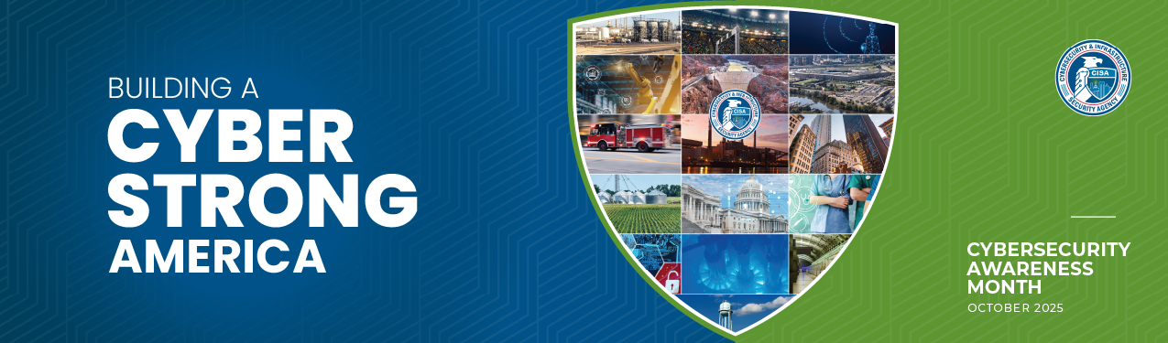

SAMPLE EMAIL ANNOUNCEMENT

*Start getting employees engaged in Cybersecurity Awareness Month by sending an email to everyone in your organization. Use the draft copy below to get started.* ***Customize it to include any cybersecurity policies and practices your organization already follows.***

**Suggested Subject Line: *Building a Cyber Strong America: Help Us Protect Against Online Threats this Cybersecurity Awareness Month***

October is Cybersecurity Awareness Month, and [Your Organization] is proud to join this international initiative to keep our people, data and systems safer online. The campaign reminds us that simple actions can make a big difference. Together, we can help protect against online threats and protect the systems we rely on every day, including critical infrastructure.

Join us as we celebrate the Cybersecurity Awareness Month 2025 theme: **Building a Cyber Strong America.** This theme highlights the need to strengthen the country's infrastructure against cyber threats, ensuring resilience and security.

You can help by taking these four essential steps:

1. **Update software**: Install updates promptly on all devices. Don’t click “Remind me later.” Updates patch vulnerabilities that attackers can exploit. Turn on automatic updates whenever possible.
2. **Use strong passwords and a password manager**: Create passwords that are at least 16 characters, random (mixed case letters, numbers, symbols), and unique for every account. Use a password manager to generate, fill, and remember them for you.
3. **Turn on multifactor authentication (MFA) wherever possible**: MFA adds an extra layer of security to your accounts. Use it everywhere it’s offered, and choose the most secure method available, such as a passkey or authenticator app.
4. **Recognize and report phishing**: Stay alert for suspicious messages. Always verify the sender before clicking links or opening attachments. If you spot a scam, use the platform’s “Report Phishing” tool.

We’ll be sharing more tips and resources throughout October. Watch your inbox and our social channels for updates.

For more information about ways to stay secure online visit [cisa.gov/cybersecurity-awareness-month](https://www.cisa.gov/cybersecurity-awareness-month).